
Tertiary Infotech Academy Pte Ltd
UEN: 201200696W
LEARNER GUIDE
For
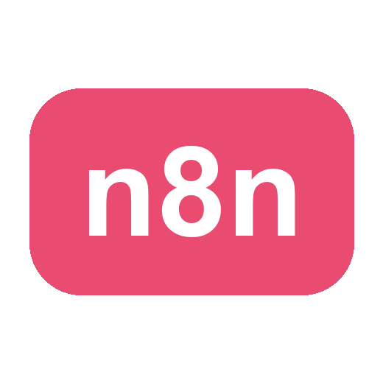
Agentic AI Automation with n8n
TGS Ref No: TGS-2023035977
Conducted by
Tertiary Infotech Academy Pte Ltd
UEN: 201200696W
Version 3.0

DOCUMENT VERSION CONTROL RECORD
Version Number | Effective Date of Release | Summary of Included Changes | Author
1.0 | 2 Feb 2023 | First version | Dr. Alfred Ang
2.0 | 16 June 2025 | Updated course title and content | Tertiary Infotech Pte Ltd
3.0 | 24 June 2026 | Restructured to 8 activities; aligned to the agentic n8n flow (Telegram agents, RAG, webhooks, APIs, guardrails); MD and DOCX aligned | Tertiary Infotech Academy Pte Ltd

TABLE OF CONTENTS
0. Before You Start — Setup & Prerequisites 6
0.1 Accounts & API keys you will need 6
0.2 Run n8n — Cloud trial OR local Docker 6
0.3 Add your credentials in n8n (do this once) 7
0.4 Download the workflows from GitHub 7
Activity 1 — Flyer with QR Code (Form → Email) 8
Goal 8
What you'll build (2 nodes) 8
Step-by-step 8
Make the QR code & flyer 9
Activity 2 — Capture Submissions in a Data Table 9
Goal 9
What you'll build (3 nodes) 10
Step-by-step 10
Activity 3a — Conditional Response (Data Table) 10
Goal 10
What you'll build 11
Step-by-step 11
Activity 3b — Conditional Response (Google Sheets / Excel) 11
Goal 12
What you'll build 12
Step-by-step 12
Activity 4a — Telegram-Triggered AI Agent (Customer Service) 12
Goal 13
Concepts — what makes an AI Agent 13
Step 1 — Create the Telegram bot 13
Step 2 — Build the workflow 13
Activity 4b — Telegram Agent + Data Table Tool (HR Admin) 14
Goal 14
Step-by-step 14
Activity 5 — Add RAG to the Telegram Agent (Two Knowledge Sources) 15
Goal 15
Concepts — RAG in one minute 15
Step-by-step 16
Activity 5b — RAG with Pinecone (Persistent Vector Database) 17
Goal 17
Why a vector database (Pinecone)? 17
Step 1 — Create a Pinecone account 17
Step 2 — Create an API key and an index 18
Step 3 — Upload your documents into Pinecone 18
Step 4 — Chat with your Pinecone knowledge base 18
Activity 6 — Website Chatbot via Webhook (Investment Advisor) 19
Goal 19
Concepts — Webhooks 19
Step-by-step 20
Activity 7 — Finance API → Telegram (AI Day-Trading Agent) 20
Goal 20
Concepts — APIs & HTTP Request 21
Step A — Get your Twelve Data API key (free) 21
Step B — Get your NewsAPI key (free) 22
Step C — Put the keys into the workflow 23
Step D — Finish & run 24
Activity 8a — Human-in-the-Loop Approval (Leave Application) 24
Goal 24
Concepts — Human in the Loop 24
Step-by-step 25
Activity 8b — Pre & Post Guardrails for the AI Agent 25
Goal 25
Concepts — Guardrails 26
Step-by-step 26
Mini Capstone Project 26
Goal 26
Deliverables 26
Assessment 27
Troubleshooting Cheat-Sheet 27
Glossary 27

Welcome! This guide takes you click-by-click through every hands-on lab in the WSQ course Agentic AI Automation with n8n (Course Code: TGS-2023035977). Over three days you will go from simple form automations to AI agents, Retrieval-Augmented Generation (RAG), webhooks, external APIs, and finally human-in-the-loop guardrails — then build a mini capstone of your own.
Work through the activities in order: each one builds on the skills (and sometimes the workflow) of the activity before it. Whenever you see a Test it box, stop and confirm your workflow behaves as described before moving on.
Note: Course flow at a glance — Day 1: Workflow Automation (Activities 1-3) + AI Agents (Activity 4). Day 2: RAG (Activity 5) · Webhooks (Activity 6) · APIs (Activity 7). Day 3: Security & Guardrails (Activity 8) + Mini Capstone.

0. Before You Start — Setup & Prerequisites

0.1 Accounts & API keys you will need
Service | Used for | Where to get it
n8n | The automation platform (all activities) | Cloud trial at n8n.io, or local Docker (see 0.2)
Gmail or Outlook | Sending emails (Activities 1-3) | Your existing mailbox; connected via OAuth2
OpenAI API key | LLM for AI agents (Activities 4-8) | platform.openai.com/api-keys (provided in class)
Google Gemini API key | Alternative LLM | aistudio.google.com/app/apikey (provided in class)
Telegram | Chat trigger for AI agents (Activities 4,5,7) | Telegram app + @BotFather
Google account | Google Sheets storage (Activity 3b) | Your Google account (training account provided)
Twelve Data | Live market data (Activity 7) | twelvedata.com — free API key
NewsAPI | Headlines & sentiment (Activity 7) | newsapi.org — free API key

0.2 Run n8n — Cloud trial OR local Docker
You have two ways to run n8n. For the course we start everyone on a cloud trial so we are productive immediately, and we also show how to self-host locally with Docker so you can keep your workflows after the trial ends.
Option A — Cloud trial (fastest). Sign up at n8n.io, create a workspace, and you land directly in the workflow editor. Note: trial Data Tables are not permanent — for anything you want to keep, store it externally (e.g. Google Sheets, see Activity 3b).
Option B — Local install with Docker Compose (persistent). Install Docker Desktop, then create a file named docker-compose.yml (a ready-made copy is in labs/n8n-installation/):
# labs/n8n-installation/docker-compose.yml
services:
n8n:
image: docker.n8n.io/n8nio/n8n
restart: always
ports:
- "5678:5678"
environment:
- N8N_SECURE_COOKIE=false
- GENERIC_TIMEZONE=Asia/Singapore
volumes:
- n8n_data:/home/node/.n8n
volumes:
n8n_data:
- Open a terminal in the labs/n8n-installation/ folder.
- Run docker compose up -d to start n8n in the background.
- Open http://localhost:5678 in your browser and create your owner account.
- Your workflows and credentials now persist in the n8n_data volume, even after restarts.
- To stop n8n, run docker compose down (your data is kept); to update, docker compose pull then up -d again.

0.3 Add your credentials in n8n (do this once)
Credentials are stored separately from workflows so you never paste secrets into nodes. Add them under Credentials → Add credential:
- Gmail / Microsoft Outlook (OAuth2) — sign in and authorise n8n to send mail on your behalf.
- OpenAI — paste your OpenAI API key. (Gemini: add a *Google Gemini (PaLM) API* credential instead.)
- Telegram — paste the bot token from @BotFather (see Activity 4a, Step 1).
- Google Sheets (OAuth2) — authorise access to your Google Sheets (Activity 3b).
- HTTP Header Auth / query params — for Twelve Data & NewsAPI keys (Activity 7).
Note: Imported workflows reference credential *names*, not your actual secrets. After importing any provided .json, re-select your own credentials on each node that needs them.

0.4 Download the workflows from GitHub
All the finished workflow .json files, the mock data (CSV) and the sample documents are in the course GitHub repository — download them so you can import and follow along:
Note: GitHub repo: https://github.com/tertiarycourses/TGS-2023035977-Agentic-AI-Automation-with-n8n · every activity lives under the `labs/` folder (one folder per activity), each with its workflow JSON, a workflow diagram, and any mock data.
- Open the repo and click Code → Download ZIP (or git clone it).
- Each activity folder under labs/ contains the importable workflow .json and its mock data.
- In n8n, open the Workflows list → Add workflow → the ⋯ menu → Import from File.
- Choose the matching .json, then re-select your own credentials on each node (OpenAI, Gmail, Telegram, etc.).
- Save, then toggle the workflow Active when the activity says to.

Activity 1 — Flyer with QR Code (Form → Email)
Folder: labs/activity1-flyer-form/

Goal
Build the smallest useful automation: an n8n Form that collects a visitor's details and emails them to an admin. You will then turn the form's URL into a QR code and put it on an event flyer.
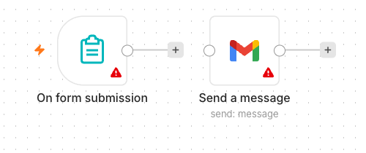
Activity 1 workflow — Form Trigger to Gmail

What you'll build (2 nodes)
Form Trigger → Gmail (Send)

Step-by-step
- Create a new workflow and name it Activity 1 — Flyer Form.
- Add an n8n Form Trigger node. Set a Form Title (e.g. "Event RSVP").
- Add four form fields: Name (text), Email (email), Phone (text), Message (textarea). Mark Name and Email required.
- Add a Gmail node, operation Send a Message, connected after the Form Trigger.
- In the Gmail node set To = the admin address, Subject = New RSVP from {{ $json.Name }}.
- Set the message body to include the submitted fields, e.g. Name: {{ $json.Name }} / Email: {{ $json.Email }} / Phone: {{ $json.Phone }} / Message: {{ $json.Message }}.
- Select your Gmail (or Outlook) credential. Save the workflow and toggle it Active.
- Open the Form Trigger node and copy the Production URL.

Make the QR code & flyer
- Open the QR code generator: https://alfredang.github.io/qrcodegenerator/
- Paste your form's Production URL and generate the QR code; download it.
- Place the QR code on a flyer so people can scan to open your form.
Note: Group Activity (3-4 per group): design a real event flyer — e.g. a bowling night — with your form's QR code and a short advert. Review a few past-student examples first, then present your flyer to the class.
✅ Test it: Scan the QR code with your phone, submit the form, and confirm the admin inbox receives the email.

Activity 2 — Capture Submissions in a Data Table
Folder: labs/activity2-data-table/

Goal
Extend Activity 1 so every submission is also saved into an n8n Data Table — your first taste of storing data, not just forwarding it.
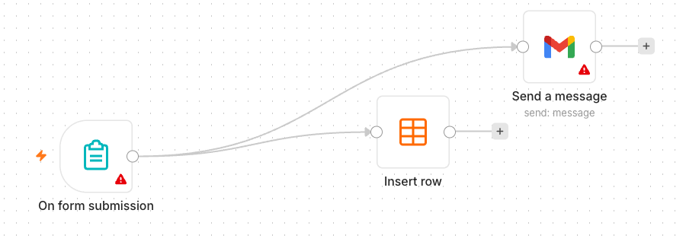
Activity 2 workflow — Form to Gmail + Data Table

What you'll build (3 nodes)
Form Trigger → Gmail (Send) and Data Table (Insert row)

Step-by-step
- In n8n open Data Tables and create a table named RSVPs with columns: Name, Email, Phone, Message.
- Duplicate your Activity 1 workflow (or continue in it).
- Add a Data Table node, operation Insert Row, and connect it after the Form Trigger (alongside Gmail).
- Map each form field to the matching column using expressions, e.g. Name → {{ $json.Name }}.
- Save and keep the workflow Active.
✅ Test it: Submit the form again and confirm a new row appears in the RSVPs Data Table and the email still sends.

Activity 3a — Conditional Response (Data Table)
Folder: labs/activity3-conditional/

Goal
Add decision-making. Ask "Will you attend?" — if Yes, save the date to the Data Table; if No, send a polite thank-you email instead.
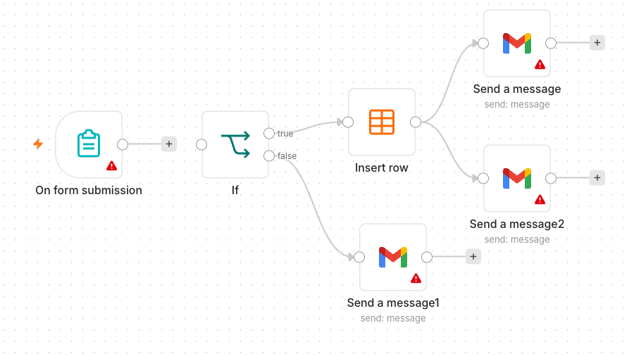
Activity 3a workflow — IF routing to Data Table / email

What you'll build
Form Trigger → IF → (true) Data Table Insert / (false) Gmail thank-you

Step-by-step
- Add an Attending? field to the form (dropdown: Yes / No).
- Add an IF node after the Form Trigger. Condition: {{ $json.Attending }} equals Yes.
- On the true output, add a Data Table → Insert Row node that saves the RSVP (Name, Email, Date).
- On the false output, add a Gmail node that sends a friendly "thanks anyway" message.
- Save and keep the workflow Active.
Note: Heads-up on persistence: data saved to a trial Data Table disappears when the trial ends. To keep it permanently you must store it externally — that is exactly what Activity 3b does with Google Sheets.
✅ Test it: Submit once with Attending = Yes (expect a new Data Table row) and once with No (expect the thank-you email).

Activity 3b — Conditional Response (Google Sheets / Excel)
Folder: labs/activity3-conditional/

Goal
Make your data persistent by replacing the Data Table with Google Sheets (or Excel). Same logic as 3a, but the "Yes" branch now appends a row to a real spreadsheet you keep.
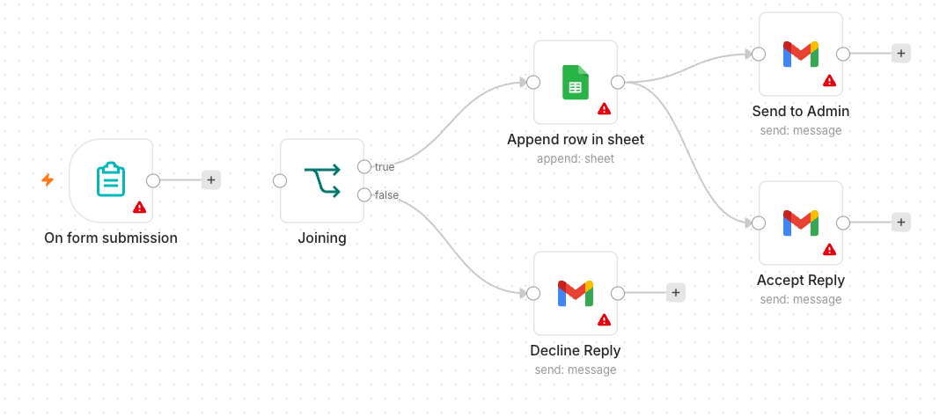
Activity 3b workflow — IF routing to Google Sheets / email

What you'll build
Form Trigger → IF → (true) Google Sheets (Append row) / (false) Gmail thank-you

Step-by-step
- In Google Drive, create a spreadsheet named Event RSVPs with a header row: Name, Email, Phone, Date.
- Back in n8n, add a Google Sheets credential (OAuth2) and authorise it.
- Take your Activity 3a workflow and on the true branch replace the Data Table node with a Google Sheets → Append Row node.
- Select your spreadsheet and sheet, then map each column to the form fields.
- Leave the false branch (thank-you email) unchanged. Save and keep Active.
Note: Microsoft 365 users can use the Microsoft Excel 365 node instead of Google Sheets — the steps are the same.
✅ Test it: Submit with Attending = Yes and confirm a new row is appended to your Google Sheet.

Activity 4a — Telegram-Triggered AI Agent (Customer Service)
Folder: labs/activity4-telegram-agent/

Goal
Build your first AI Agent: a simple customer-service chatbot you talk to from Telegram. The agent uses an LLM, short-term memory, and a system instruction that defines its persona.
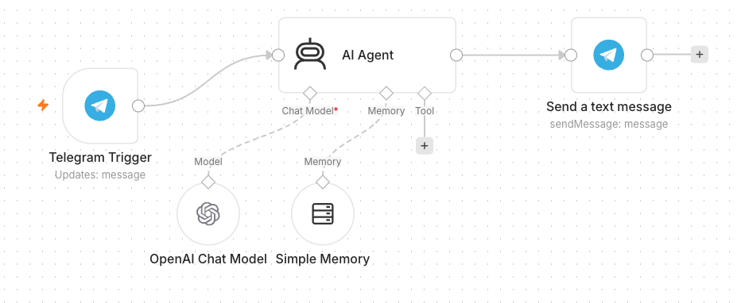
Activity 4a workflow — Telegram-triggered AI Agent

Concepts — what makes an AI Agent
- LLM — the model that generates replies (OpenAI gpt-4.1-mini or Google Gemini).
- Memory — remembers the recent conversation so follow-up questions make sense.
- Tools — optional actions the agent can call (added in Activity 4b).
- System Instruction — the agent's role, tone, and rules.

Step 1 — Create the Telegram bot
- In Telegram, open @BotFather → /newbot, give it a name and username, and copy the bot token.
- In n8n add a Telegram credential and paste the token.

Step 2 — Build the workflow
- Add a Telegram Trigger node (it fires on each incoming message). Select your Telegram credential.
- Add an AI Agent node connected after the trigger.
- Attach an OpenAI Chat Model (or Google Gemini Chat Model) as the agent's model.
- Attach a Simple Memory node so the agent recalls the conversation.
- Write the System Instruction, e.g. "You are a friendly customer-service assistant for MyCompany. Answer concisely and politely."
- Add a Telegram → Send Message node after the agent; set Chat ID = {{ $json.message.chat.id }} and Text = the agent's output.
- Save and toggle Active.
✅ Test it: Message your bot in Telegram (e.g. "What are your opening hours?") and confirm it replies.

Activity 4b — Telegram Agent + Data Table Tool (HR Admin)
Folder: labs/activity4-telegram-agent/

Goal
Give the agent a tool: an employee Data Table it can look up. Now the same Telegram bot can answer HR-admin questions like "What department is Alice in?" by querying real data.
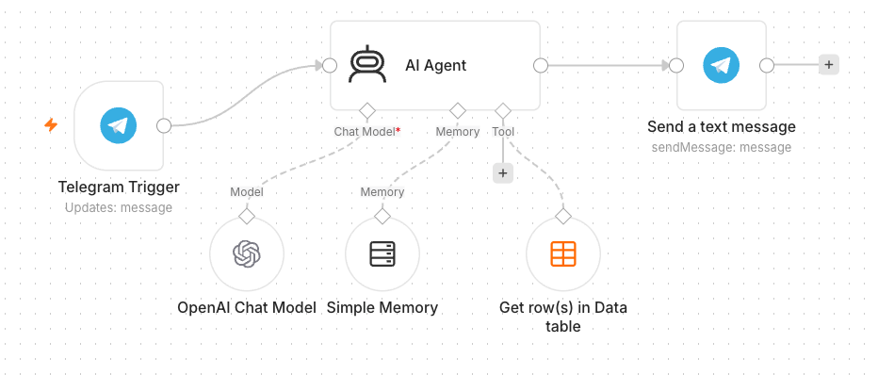
Activity 4b workflow — Agent with a Data Table tool

Step-by-step
- Create a Data Table named Employees. Either reuse data from Activity 2, or upload the provided mock-hr-employees.csv (100 records) — regenerate it any time with make_mock_data.py.
- Open your Activity 4a workflow.
- Add a Data Table Tool and attach it to the AI Agent's Tool input.
- Point the tool at the Employees table and describe it in the tool description, e.g. "Look up employee details by name or department."
- Update the System Instruction: "You are an HR admin assistant. Use the Employees tool to answer questions about staff. If the data is not found, say so."
- Save and keep Active.
✅ Test it: Ask the bot "Which department is <a name from the CSV> in?" and confirm it answers from the table.

Activity 5 — Add RAG to the Telegram Agent (Two Knowledge Sources)
Folder: labs/activity5-rag/

Goal
Upgrade the agent with Retrieval-Augmented Generation (RAG) so it can answer from documents (policy PDFs/FAQs) as well as the Data Table. The agent must route to the right source for each question.
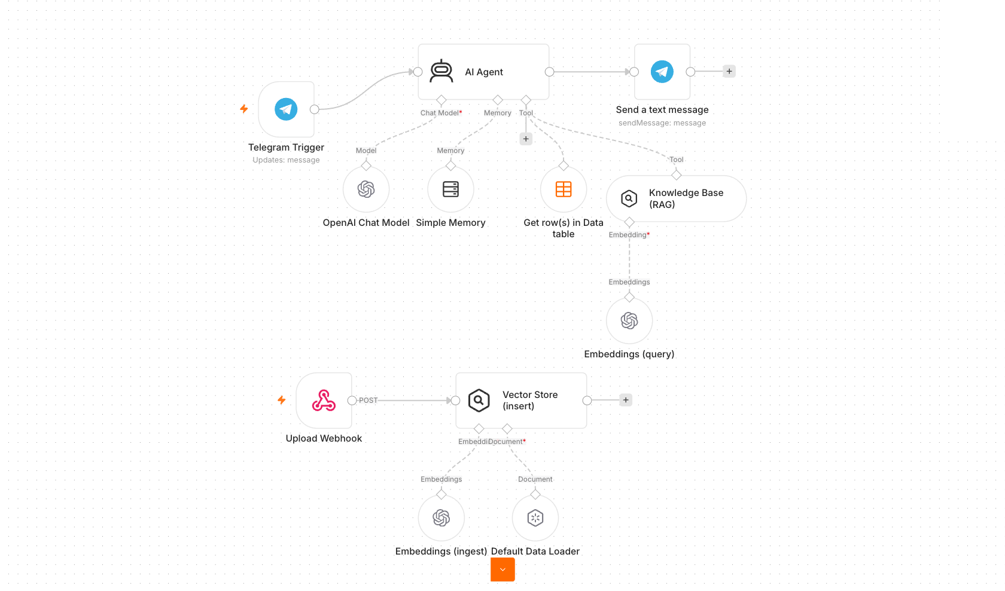
Activity 5 workflow — Agent with RAG + Data Table sources

Concepts — RAG in one minute
- Tokenization — text is split into tokens the model can process.
- Embeddings — each chunk of a document becomes a vector (a list of numbers capturing meaning).
- Vector store — those vectors are saved so the most relevant chunks can be retrieved for a question.
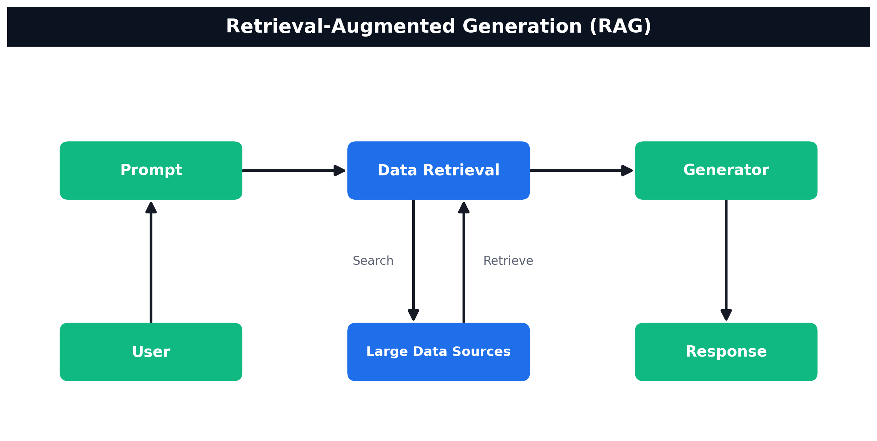
How RAG works — User → Prompt → Data Retrieval (search/retrieve over your data sources) → Generator → Response

Step-by-step
- Prepare knowledge documents. Use the provided MyCompany-HR-SOP.docx and MyCompany-IT-Support-FAQ.docx, or generate fresh ones with Claude Code (e.g. an employee-benefits FAQ or product info).
- Build the ingestion path: an upload point → Embeddings (OpenAI) → Vector Store (Insert) with a Default Data Loader so your documents are embedded and stored.
- In your Telegram agent, add a Vector Store retrieval tool (the RAG source) alongside the existing Data Table tool — the agent now has two data sources.
- Rewrite the System Instruction to route correctly: "Use the Knowledge Base tool for policy/FAQ questions and the Employees tool for staff-record questions. Never mix the two."
- Save and keep Active.
Note: Get a few learners to present their chatbot and show it answering both a policy question (RAG) and a staff-record question (Data Table).
✅ Test it: Ask a policy question ("How many days of annual leave do I get?") and a record question ("What is Alice's role?") and confirm each is answered from the correct source.

Activity 5b — RAG with Pinecone (Persistent Vector Database)
Folder: labs/activity5-rag/ · workflows Activity5b-Pinecone-Upload.json (ingest) + Activity5b-Pinecone-RAG.json (chat)

Goal
Activity 5 used an in-memory vector store that resets when the workflow restarts. Here you swap it for Pinecone, a managed cloud vector database, so your knowledge base persists and scales. You upload documents into a Pinecone index once, then the Telegram agent answers from it.
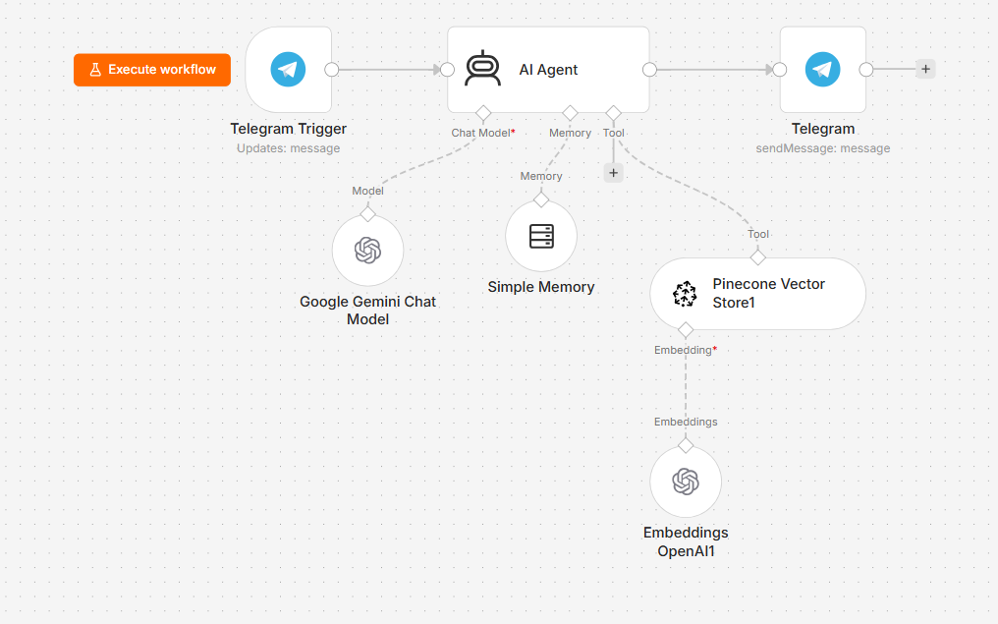
Activity 5b workflow — Telegram agent answering from a Pinecone vector store (gpt-4.1-mini)

Why a vector database (Pinecone)?
- An in-memory store is fine for a demo but is lost on restart.
- Pinecone stores your embeddings in the cloud — persistent, fast, scales to millions of vectors.
- Same RAG idea: embed documents once, then retrieve the closest chunks for each question.

Step 1 — Create a Pinecone account
- Open https://www.pinecone.io/ and click Sign Up (the free Starter tier is enough for this lab).
- Register with your email (or Google/GitHub) and verify the account.
- You land in the Pinecone console at https://app.pinecone.io.
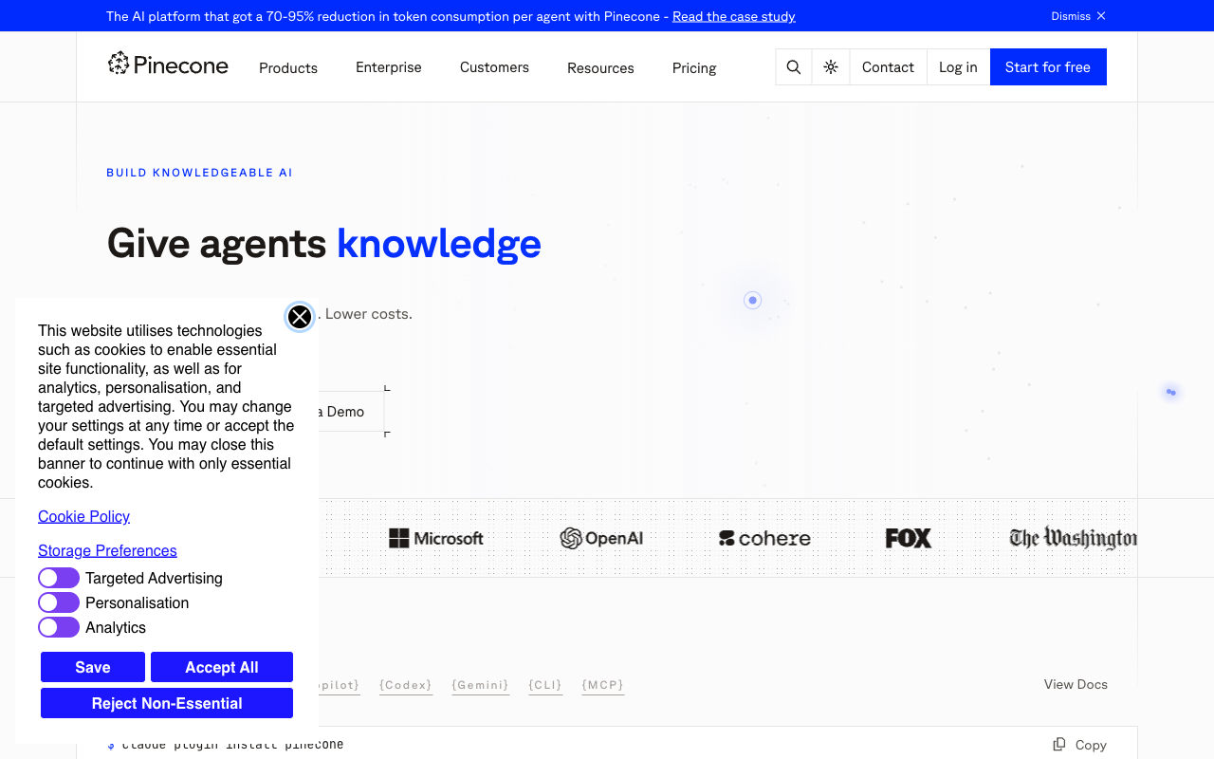
Pinecone — the managed vector database; sign up for the free Starter tier

Step 2 — Create an API key and an index
- In the console, open API Keys and create / copy an API key (you'll paste it into n8n).
- Open Indexes → Create index and give it a name, e.g. n8n-course.
- Set Dimensions = 1536 to match OpenAI text-embedding-3-small (the embeddings used in this lab).
- Set Metric = cosine, then create the index.
Note: The embedding model on both the upload and the chat workflows must be the same (here, OpenAI text-embedding-3-small = 1536 dims) — otherwise the vector dimensions won't match the index.

Step 3 — Upload your documents into Pinecone
- Import Activity5b-Pinecone-Upload.json.
- Add a Pinecone credential (paste your API key) and select your n8n-course index on the Pinecone node.
- Add your OpenAI credential on the Embeddings node.
- Provide your documents (e.g. the HR SOP / IT FAQ) and run the workflow to embed and insert them into Pinecone.

Step 4 — Chat with your Pinecone knowledge base
- Import Activity5b-Pinecone-RAG.json (Telegram → AI Agent + Pinecone Vector Store tool → reply).
- Select the same Pinecone index and credential, your OpenAI key (gpt-4.1-mini), and your Telegram credential.
- Save and toggle Active.
✅ Test it: Upload a document, then ask the Telegram bot a question only answerable from it — the answer is retrieved from your Pinecone index, and it survives a workflow restart.

Activity 6 — Website Chatbot via Webhook (Investment Advisor)
Folder: labs/activity6-investment-advisor/ · Reference: https://alfredang.github.io/n8n-investmentadvisor/

Goal
Expose an AI agent to a public website using a Webhook. The provided one-page Investment Advisor site has an enquiry form and a floating chatbot; both POST to a single n8n webhook, which routes to an email-the-advisor path and an AI-chat path.
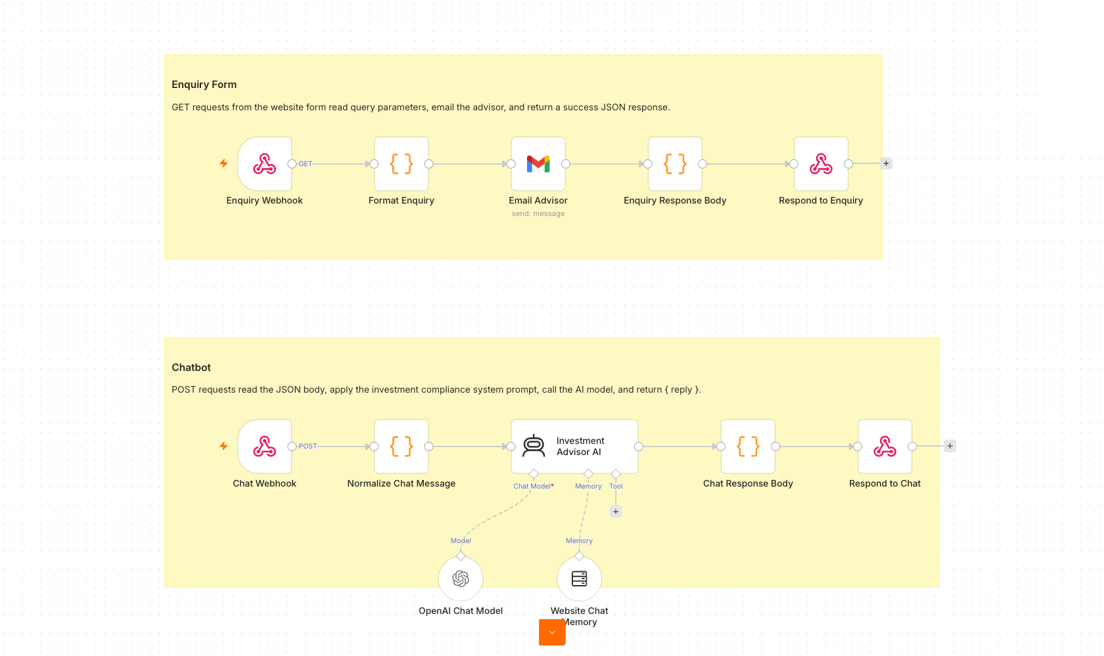
Activity 6 workflow — Webhook chatbot + enquiry

Concepts — Webhooks
- A Webhook is a URL that external systems (a website, another app) call to trigger your workflow.
- Use cases: website chat, form submissions, payment events, GitHub/Stripe notifications — any external trigger.
- Pair the Webhook trigger with a Respond to Webhook node to send a reply back to the caller.

Step-by-step
- Import Activity6-Investment-Advisor.json into n8n.
- Open the Webhook node(s) and ensure Allowed Origins (CORS) is * so the browser page can call it.
- Re-select your OpenAI and Gmail credentials on the AI Agent and Email nodes.
- Review the agent's compliance system instruction (no guaranteed returns, no personalised advice).
- Save, toggle Active, and copy the webhook Production URL.
- Update Production URL inside the script.js Webhook URL
- Open index.html from the activity folder, click the settings/gear, and paste your webhook URL.
Note: Get a few learners to present their live website and chatbot.
✅ Test it: On the website, send a chat message and submit the enquiry form; confirm the bot replies and the advisor receives the enquiry email.

Activity 7 — Finance API → Telegram (AI Day-Trading Agent)
Folder: labs/activity7-finance-advisor/ · Reference: https://alfredang.github.io/n8n-financeadvisor/

Goal
Combine APIs/HTTP Requests with an AI agent. Ask the Telegram bot about a stock; it resolves the ticker, pulls multi-timeframe candles from Twelve Data and headlines from NewsAPI, and replies with a Buy / Sell / Hold call and reasoning. A companion dashboard shows live price and charts.
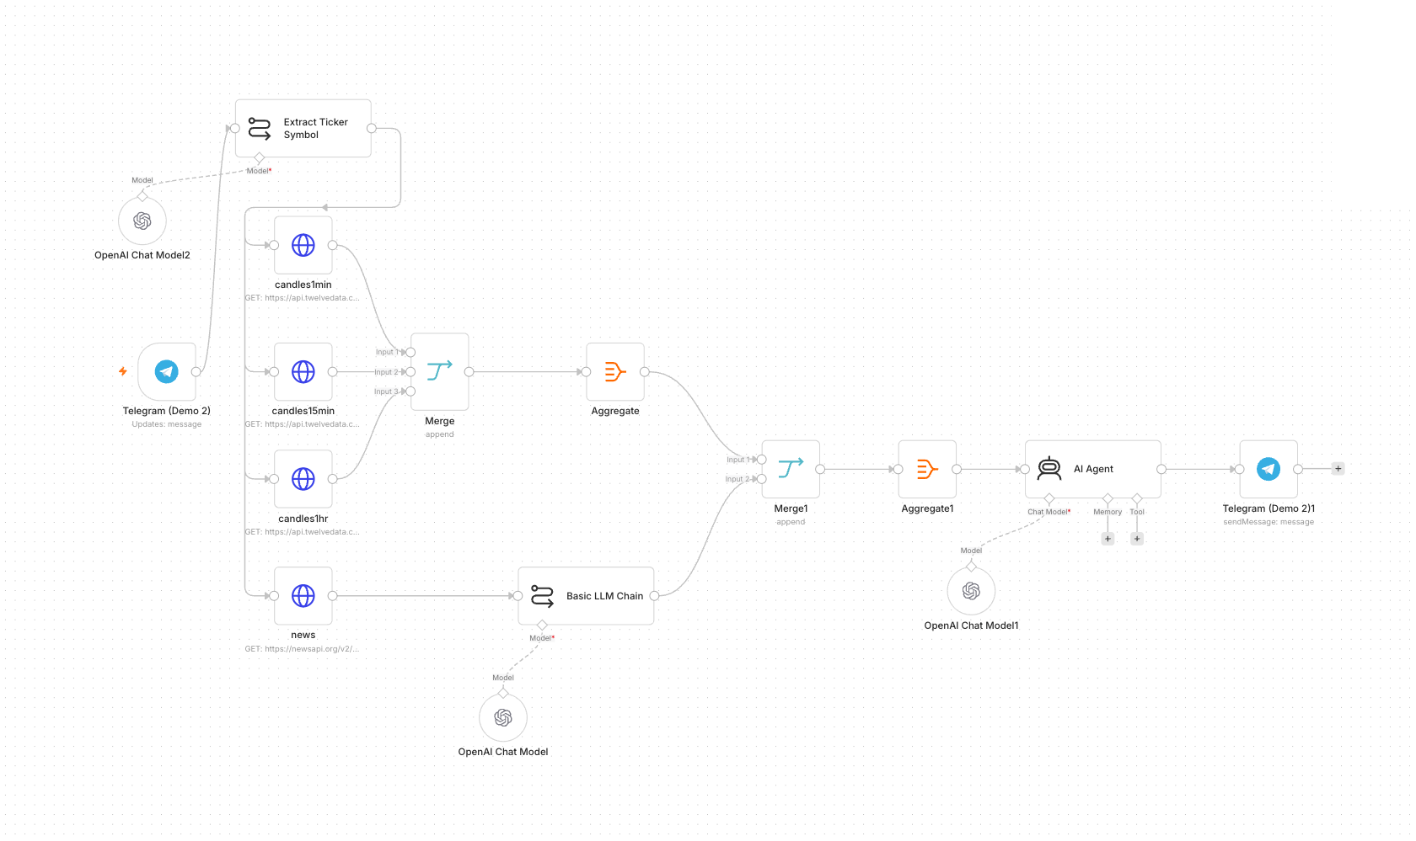
Activity 7 workflow — Finance API to Telegram day trader

Concepts — APIs & HTTP Request
- An API lets your workflow request data from another service over HTTP.
- The HTTP Request node calls an endpoint with a method (GET/POST), headers, and query parameters.
- API keys authenticate you — keep them in credentials, never hard-coded.

Step A — Get your Twelve Data API key (free)
- Open https://twelvedata.com/ and click Sign Up (the free Basic plan is enough for this lab).
- Register with your email and verify the account.
- Once logged in, go to https://twelvedata.com/account/api-keys (Account → API Keys).
- Copy the API key shown there — you'll paste it into the workflow in Step C.
Note: The free Twelve Data plan allows ~8 requests/minute and ~800 calls/day — plenty for testing. All three candle requests in this activity use the same Twelve Data key.
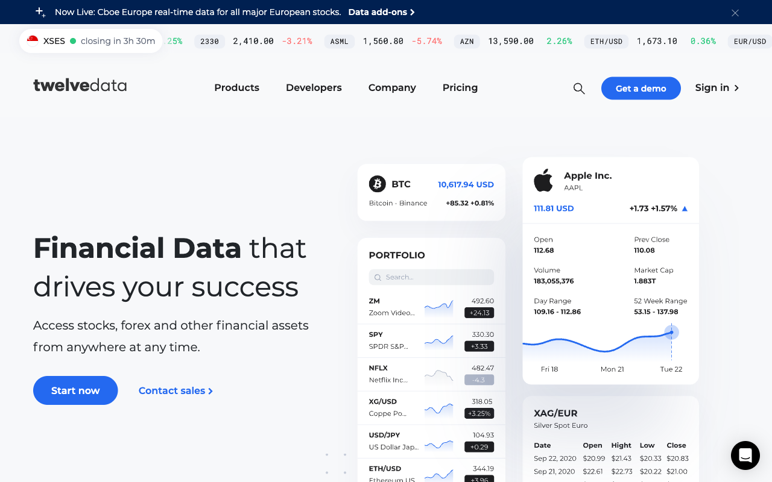
Twelve Data home page — click Sign Up, then Account → API Keys to copy your key

Step B — Get your NewsAPI key (free)
- Open https://newsapi.org/ and click Get API Key.
- Register with your email (choose the free Developer plan).
- Your key appears on your account page at https://newsapi.org/account — copy it.
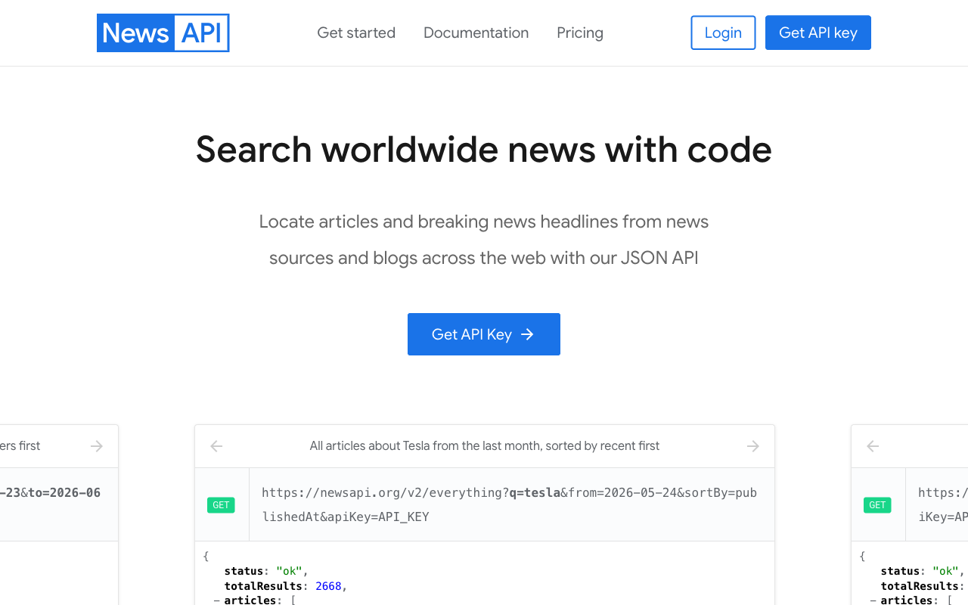
NewsAPI home page — click Get API Key and register for the free Developer plan

Step C — Put the keys into the workflow
Import Activity7-Finance-Advisor.json into n8n, then set the keys. Twelve Data and NewsAPI are configured in two different ways:
C1 — Twelve Data (3 HTTP Request nodes). The key is a query parameter you paste directly:
- Open the candles1min node (an HTTP Request node).
- Scroll to Query Parameters and find the parameter named `apikey`.
- Replace its value YOUR_TWELVEDATA_API_KEY with the key you copied from Twelve Data.
- Repeat for candles15min and candles1hr — all three call Twelve Data and need the same key.
Note: Tip — set it once: create a Query Auth credential (Name = apikey, Value = your Twelve Data key), then on each candle node set Authentication → Generic Credential Type → Query Auth and delete the inline apikey parameter. That way the key lives in one place.
C2 — NewsAPI (the `news` node). The key is stored as a credential:
- Open the news HTTP Request node. Authentication is already set to Generic Credential Type → Query Auth.
- Click the Credential dropdown → Create New Credential.
- Set Name = apiKey and Value = your NewsAPI key, then Save. (NewsAPI expects the key in a query parameter called apiKey.)
- Back on the news node, make sure your new credential is selected.

Step D — Finish & run
- Re-select your own OpenAI and Telegram credentials on the model and Telegram nodes.
- Review the flow: Telegram Trigger → Extract Ticker (LLM) → HTTP candles (1m/15m/1h) + HTTP news → Aggregate/Merge → AI Agent → Telegram reply.
- Save the workflow and toggle it Active.
- *(Optional)* open index.html, click the gear, and paste your Twelve Data key + Telegram bot username for the dashboard.
✅ Test it: Message the bot "Should I buy AAPL?" and confirm it returns a recommendation with reasoning. If you get a 401/429 from an HTTP node, re-check the corresponding API key (401 = wrong key, 429 = rate limit).

Activity 8a — Human-in-the-Loop Approval (Leave Application)
Folder: labs/activity8-guardrails/

Goal
Add a human approval step so the automation pauses for a person to decide. We model a leave-application approval: a request comes in, a manager is asked to approve, and the flow only continues on approval.
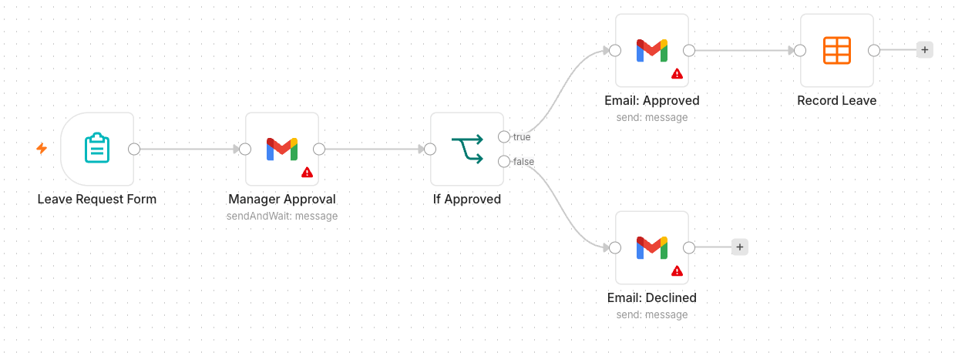
Activity 8a workflow — human-in-the-loop approval

Concepts — Human in the Loop
- Some actions are too sensitive to fully automate — money, hiring, sending on someone's behalf.
- A human-in-the-loop step pauses the workflow and waits for a person to Approve or Reject.
- n8n provides Send and Wait for Response (e.g. via email/Telegram) to capture that decision.

Step-by-step
- Start a workflow with a Form Trigger (or Telegram) collecting: Employee, Dates, Reason.
- Add a Gmail → Send and Wait for Response (Approval) node addressed to the manager, with Approve / Reject buttons.
- On Approved, record the leave (Data Table or Google Sheet) and email a confirmation to the employee.
- On Rejected, email the employee that the request was declined.
- Save and keep Active.
Note: Get a few learners to present their approval flow.
✅ Test it: Submit a leave request, approve it from the manager email, and confirm the employee gets a confirmation.

Activity 8b — Pre & Post Guardrails for the AI Agent
Folder: labs/activity8-guardrails/

Goal
Wrap an AI agent with guardrails so unsafe input never reaches the model and unsafe output never reaches the user. You add a pre-check before the agent and a post-check after it.
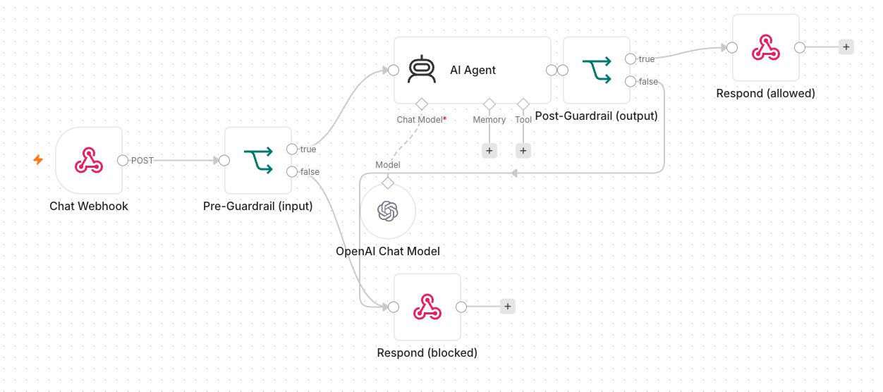
Activity 8b workflow — pre/post guardrails around the agent

Concepts — Guardrails
- Pre-guardrail — validate/sanitise the *input* (block prompt-injection, PII, banned topics) before the LLM.
- Post-guardrail — check the *output* (no secrets, no disallowed content) before it is sent.
- If a guardrail fails, route to a safe fallback (a canned reply, or human review).

Step-by-step
- Take the Activity 6 webhook agent (or the Telegram agent).
- Before the AI Agent, add a check node (a Guardrails node, or an LLM/If classifier) that inspects the user message; on a violation, branch to a safe canned response instead of the agent.
- After the AI Agent, add a second check that scans the reply for secrets/policy violations; on a violation, replace it with a safe message (or send it for human review as in 8a).
- Only send the reply to the user when both guardrails pass.
- Save and keep Active.
✅ Test it: Send a normal question (passes through) and a disallowed one (blocked by the pre-guardrail with a safe reply).

Mini Capstone Project
Folder: labs/mini-capstone/

Goal
Bring it together. In small groups, design and build an end-to-end automation that uses what you learned: a trigger (form/Telegram/webhook), an AI agent with at least one tool or RAG source, an external API or storage, and a guardrail or human-in-the-loop step. A worked example — an Issue Reporting flow (form + image → Postgres, with a retrieval API and gallery) — is provided in the folder.

Deliverables
- A working n8n workflow (exported .json).
- A short demo of the happy path and at least one safety/guardrail case.
- A 3-5 minute presentation: problem, design, what you'd improve.

Assessment
Your capstone and the activities across the three days are assessed against the course learning outcomes: workflow design, AI agent / RAG integration, webhook & API use, and the application of security guardrails.

Troubleshooting Cheat-Sheet
Symptom | Likely cause & fix
Browser page can't reach the webhook | Set the Webhook node's Allowed Origins (CORS) to *; use the Production URL with the workflow Active.
Imported workflow errors on run | Re-select your own credentials on every node; imported credential IDs won't match.
AI agent gives empty/odd replies | Check the model credential is valid and the System Instruction is set; confirm Memory is attached.
Telegram bot doesn't respond | Workflow must be Active; the Telegram credential token must match the bot; check the chat ID expression.
Data Table data disappeared | Trial Data Tables are not permanent — use Google Sheets/Excel (Activity 3b) for persistence.
API returns 401/429 | 401 = wrong/missing API key; 429 = rate limit — wait, or reduce request frequency.

Glossary
Term | Meaning
Trigger | The node that starts a workflow (Form, Webhook, Telegram, Schedule, Manual).
Node | A single step/block in a workflow (an action, a logic gate, a trigger).
Action | A node that does something — send email, insert a row, call an API.
Flow / Connection | The wires linking nodes, defining execution order and data passing.
AI Agent | A node that uses an LLM plus memory and tools to reason and act.
LLM | Large Language Model — the AI that understands and generates text.
RAG | Retrieval-Augmented Generation — answering from your documents via a vector store.
Embedding | A numeric vector representing the meaning of a piece of text.
Vector store | A database of embeddings used to retrieve relevant chunks.
Webhook | A URL that external systems call to trigger a workflow.
Guardrail | A safety check on an agent's input (pre) or output (post).
Human in the loop | A pause for a person to approve/reject before the flow continues.
You're done — congratulations! Keep your local n8n running to continue building your own agents.

